Cloudbees Build Errors
Thursday, July 11, 2024
11:10 AM

Error:

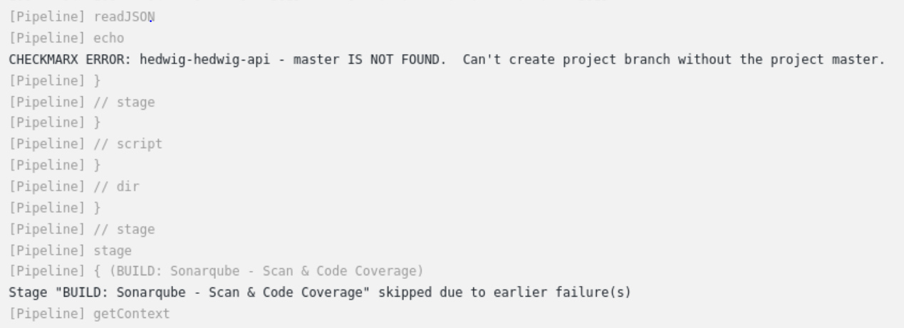

Solution:

This is normal to be seen in the beginning for the first 2 or 3 times, until Checkmarx has created all the projects for Hedwig-api.
That said, once we run the build again this error should clear itself out.

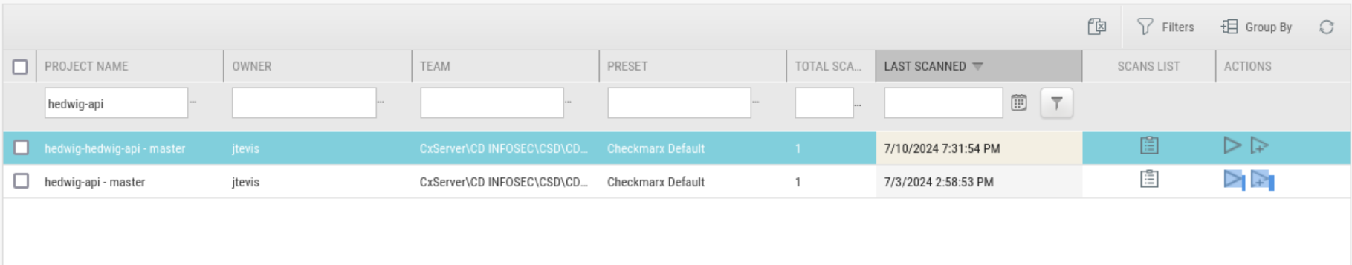

======================================================================================================================

Error:

https://cloudbees.pb.lz.us-cert.gov/ctmart/job/flarecloud/job/directory/job/develop/50/consoleFull

You can search ‘2.7.10’ and it should pop up.

I was working with Parker on getting those exceptions in I asked for earlier today, when he brought something to my attention.
In the log file of the latest directory service build, an older and unused version of the spring-boot-starter-parent pom is being pulled:

We are currently using version 3.1.10 across all of the FLAREcloud-infra services, so we are not sure why this is being pulled.
I checked the dependency tree of this same log, and only version 3.1.10 of that package is in it. I additionally did a search across the entirety of the FLAREcloud-infra repo, and no hits came back for “2.7.10.”

I took a further look at the log and noticed this is being pulled in during the CodeDx scan step and not during the maven build step like I originally assumed.
Scrolling up in the log, this is the last command ran before poms start getting pulled from artifactory:
+ cdxgen -t java -r --deep --resolve-class -o application_bom.json --required-only -p

Would you have any idea why an old and unused dependency would be being pulled from artifactory?
We think maybe this might be the reason the Dependency-Track tool is flagging CVEs for dependencies that do not match the ones we have in our pom files.

I also checked the latest enhancement service log and it had the 2.7.10 pom being pulled from artifactory in there too, which makes me assume it is being pulled in all of the FLAREcloud-infra services.
I am not sure if this is the only outdated pom being pulled, but it’s the first one we noticed.

Let me know what you think and what we can do to fix this.
Thank you.

Solution:

I cloned the repo and checked its dependencies as shown below:

The version 2.7.10 of spring-boot-starter-parent is introduced by this:
springdoc-openapi 1.7.0

which in turn is introduced by xor.bcmc:

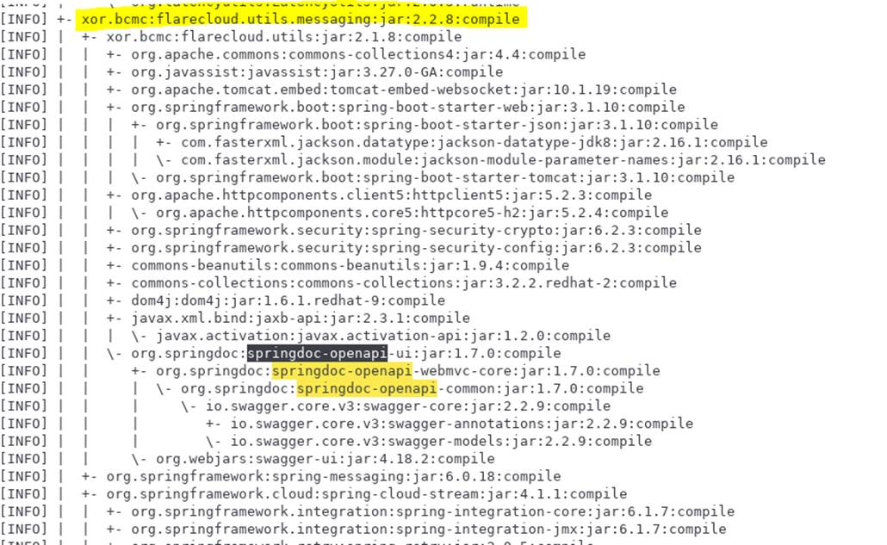

I added an exclusion in this dependency:

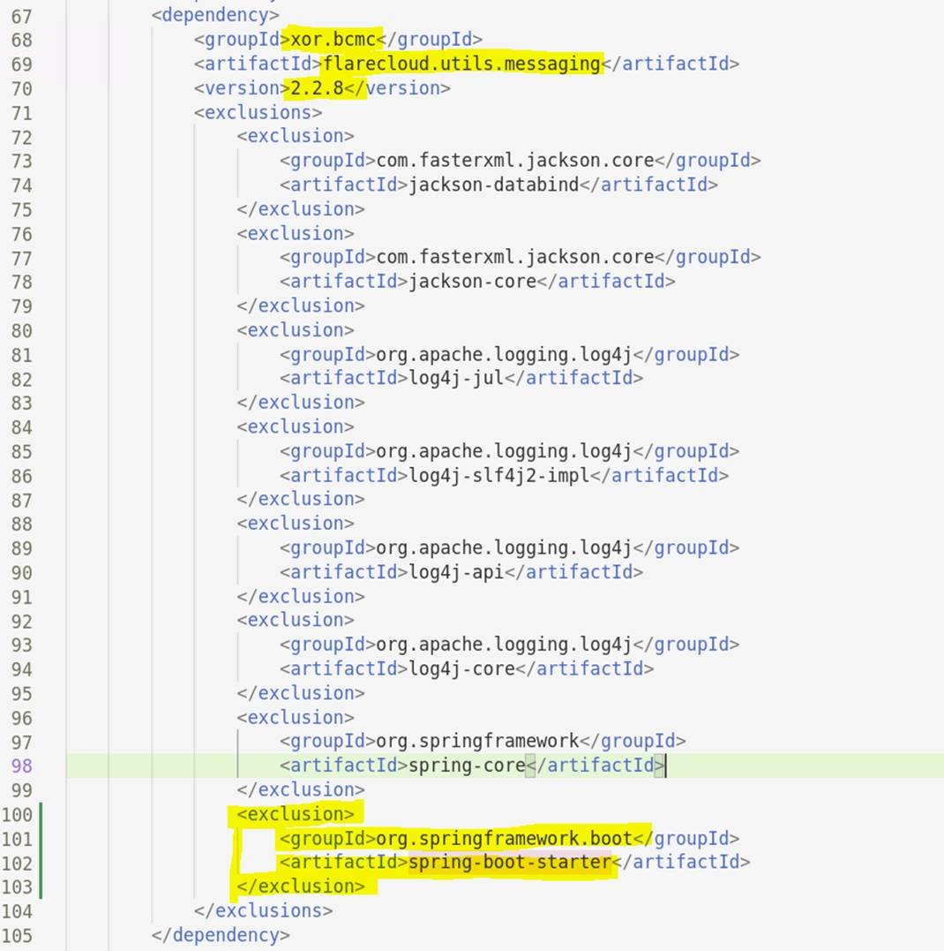

It seems solved the problem. Please try it out.

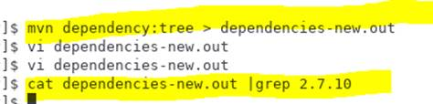

I saw springdoc-openapi was downloaded right before spring-boot-starter-parent 2.7.10.

Then I searched where springdoc-openapi was introduced and found xor.bcmc which led me to consider adding an exclusion to it.

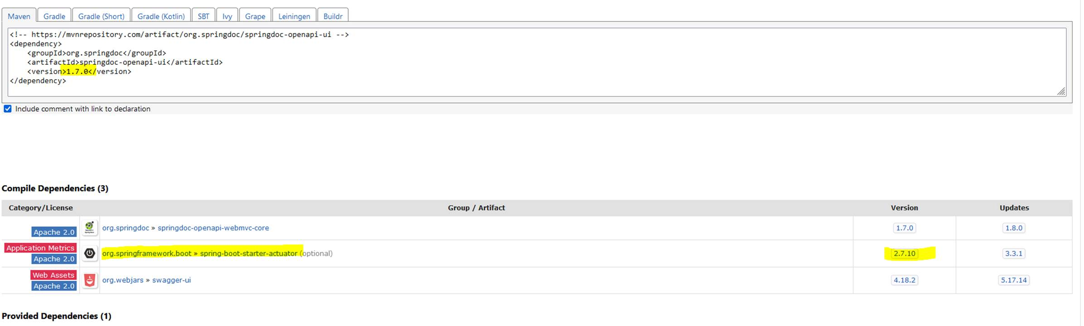

===========================================================================================================================

Error:

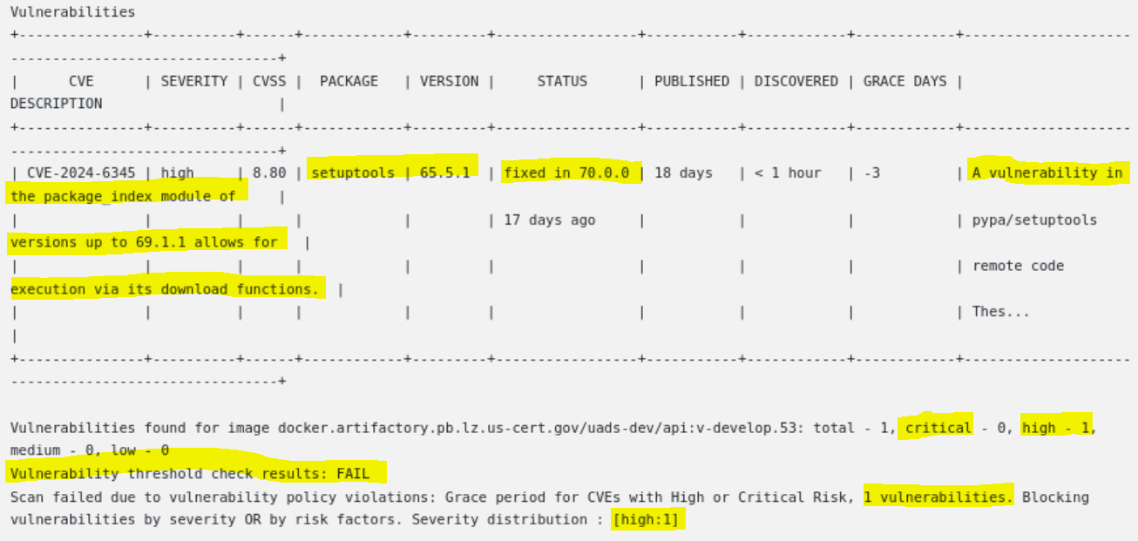

[root@a-1spquvzhx6ii docker.service.d]# docker pull docker.artifactory.pb.lz.us-cert.gov/ubi8/python-311:1-68.1721725204
1-68.1721725204: Pulling from ubi8/python-311
8694db102e5b: Pull complete
7027f4e4058b: Pull complete
be575238ea98: Pull complete
f5222820962e: Pull complete
Digest: sha256:d2cc88eb4aed73031743d7b8de886f9d0cb03e86784aef751234dcfe9239cb95
Status: Downloaded newer image for docker.artifactory.pb.lz.us-cert.gov/ubi8/python-311:1-68.1721725204
docker.artifactory.pb.lz.us-cert.gov/ubi8/python-311:1-68.1721725204

[root@a-1spquvzhx6ii docker.service.d]# docker images
REPOSITORY TAG IMAGE ID CREATED SIZE
docker.artifactory.pb.lz.us-cert.gov/ubi8/python-311 1-68.1721725204 4ab69be404a6 10 days ago 923MB
docker.artifactory.pb.lz.us-cert.gov/nginx latest e4720093a3c1 5 months ago 187MB
[root@a-1spquvzhx6ii docker.service.d]# docker run -it 4ab69be404a6 bash

(app-root) find / -name "*setuptools*" 2>/dev/null
/opt/app-root/lib/python3.11/site-packages/pip/_internal/utils/__pycache__/setuptools_build.cpython-311.pyc
/opt/app-root/lib/python3.11/site-packages/pip/_internal/utils/setuptools_build.py
/opt/app-root/lib/python3.11/site-packages/setuptools
/opt/app-root/lib/python3.11/site-packages/setuptools-65.5.1.dist-info
/usr/lib/python3.6/site-packages/setuptools
/usr/lib/python3.6/site-packages/setuptools-39.2.0.dist-info
/usr/lib/python3.11/site-packages/pip/_internal/utils/__pycache__/setuptools_build.cpython-311.opt-1.pyc
/usr/lib/python3.11/site-packages/pip/_internal/utils/__pycache__/setuptools_build.cpython-311.pyc
/usr/lib/python3.11/site-packages/pip/_internal/utils/setuptools_build.py
/usr/lib/python3.11/site-packages/setuptools
/usr/lib/python3.11/site-packages/setuptools-65.5.1.dist-info
/usr/share/licenses/platform-python-setuptools
/usr/share/licenses/python3-setuptools-wheel
/usr/share/licenses/python3.11-setuptools
/usr/share/licenses/python3.11-setuptools-wheel
/usr/share/python3-wheels/setuptools-39.2.0-py2.py3-none-any.whl
/usr/share/python3.11-wheels/setuptools-65.5.1-py3-none-any.whl

Solution:

I updated the Dockerfile of UADS-api project and added setuptools to be upgraded.

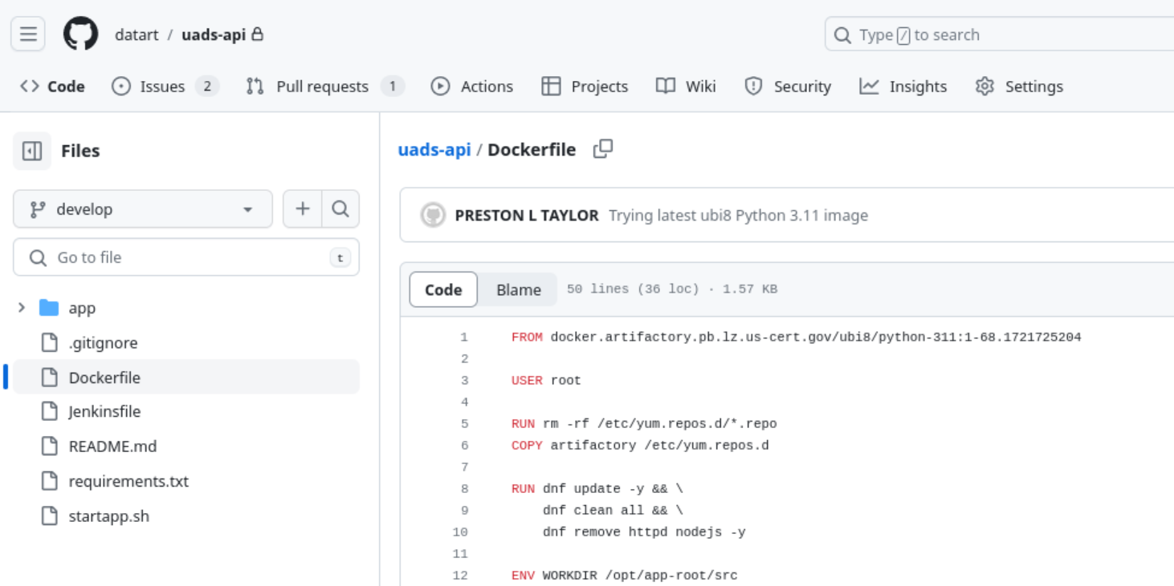

I added setuptools to be upgraded in the Dockerfile of UADS-api project.
Then, I opened a Pull Request against "Develop" branch so that they can merge the new update.

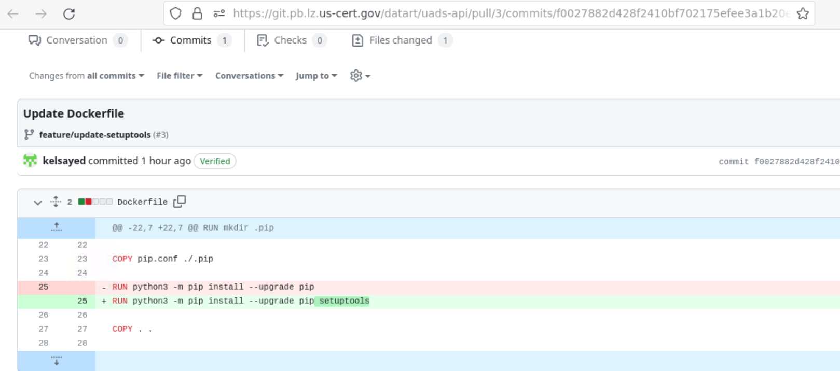

Then, I ran a Build against my branch "feature/update-setuptools", and the build was successful and it passed the Twistlock scan.

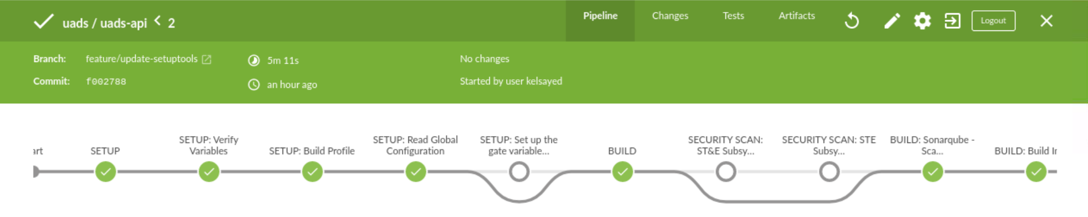

===========================================================================================================================

Error:

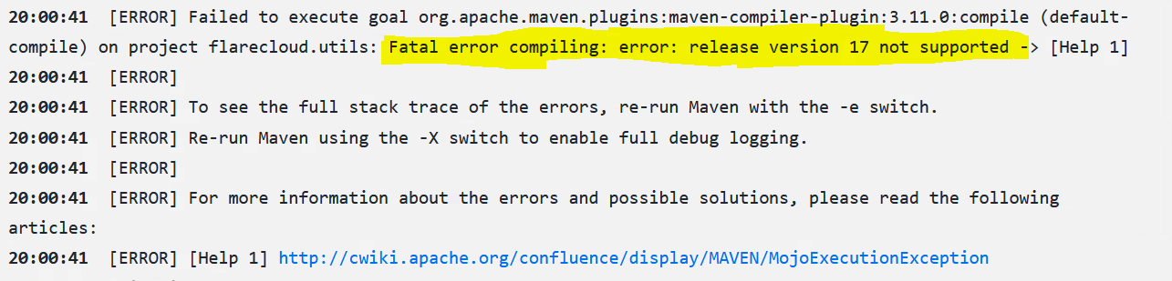

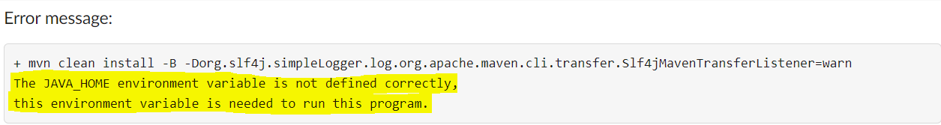

Solution:

We had to reinstall Java-17 inside the Maven Docker Image for the Maven Agent Worker, and push the new Image to Artifactory.
Then, we changed the Image tags inside all the Jenkins Pipelines to use the Latest Maven Docker Image Tag (PI24-4.20240809).

- Reinstalling Java-17 inside Maven Docker Image
  - I added java-17-openjdk java-17-openjdk-devel to the Docker file of the Maven Jenkins Agent Worker.

- 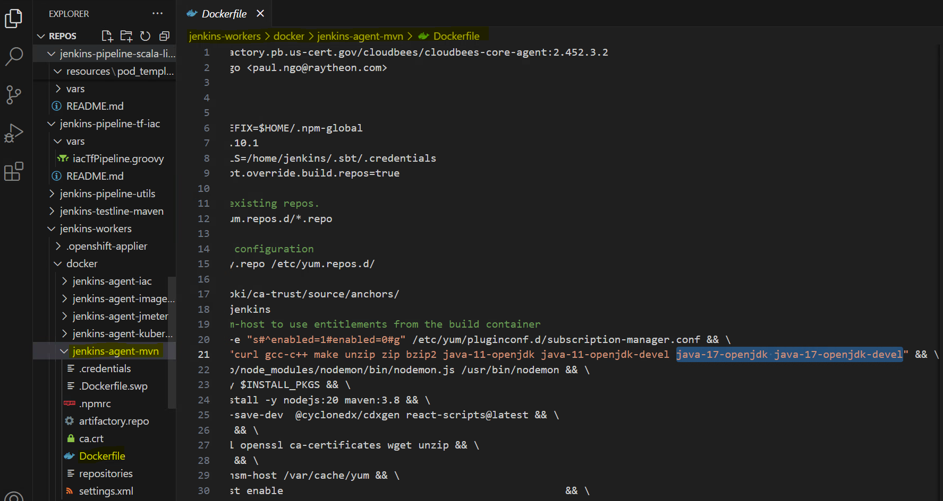

- Building the new Maven Docker Image for the Maven Jenkins Agent Worker.

- docker build . -t docker.artifactory.pb.us-cert.gov/jenkins-workers/jenkins-agent-mvn:PI24-4.20240809

- Pushing the New Docker image to Artifactory.

- docker push docker.artifactory.pb.us-cert.gov/jenkins-workers/jenkins-agent-mvn:PI24-4.20240809

All the Cloudbees Builds were Successful after updating all the following Pipelines with the new Docker Image Tag (PI24-4.20240809).

- Updating Jenkins Pipelines - Master Branch
  - Jenkins-pipeline-codecommit-to-ghe-sync
  - Jenkins-pipeline-java
  - Jenkins-pipeline-java-lambda
  - Jenkins-pipeline-java-library
  - Jenkins-pipeline-scala-library
  - Jenkins-testline-maven

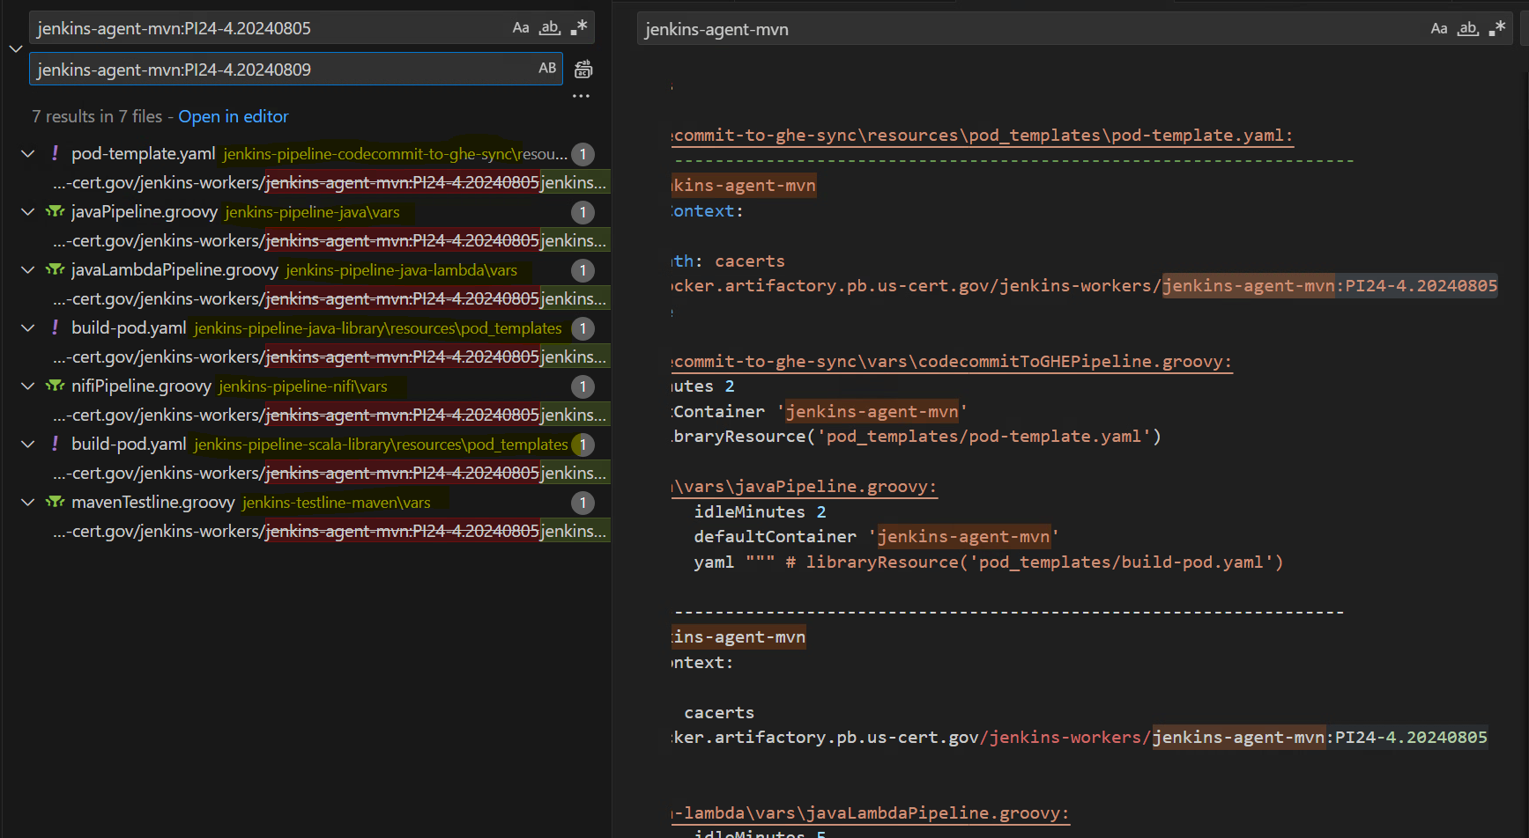

- Updating Jenkins Pipelines - Develop Branch
  - Jenkins-pipeline-java
  - Jenkins-pipeline-java-library

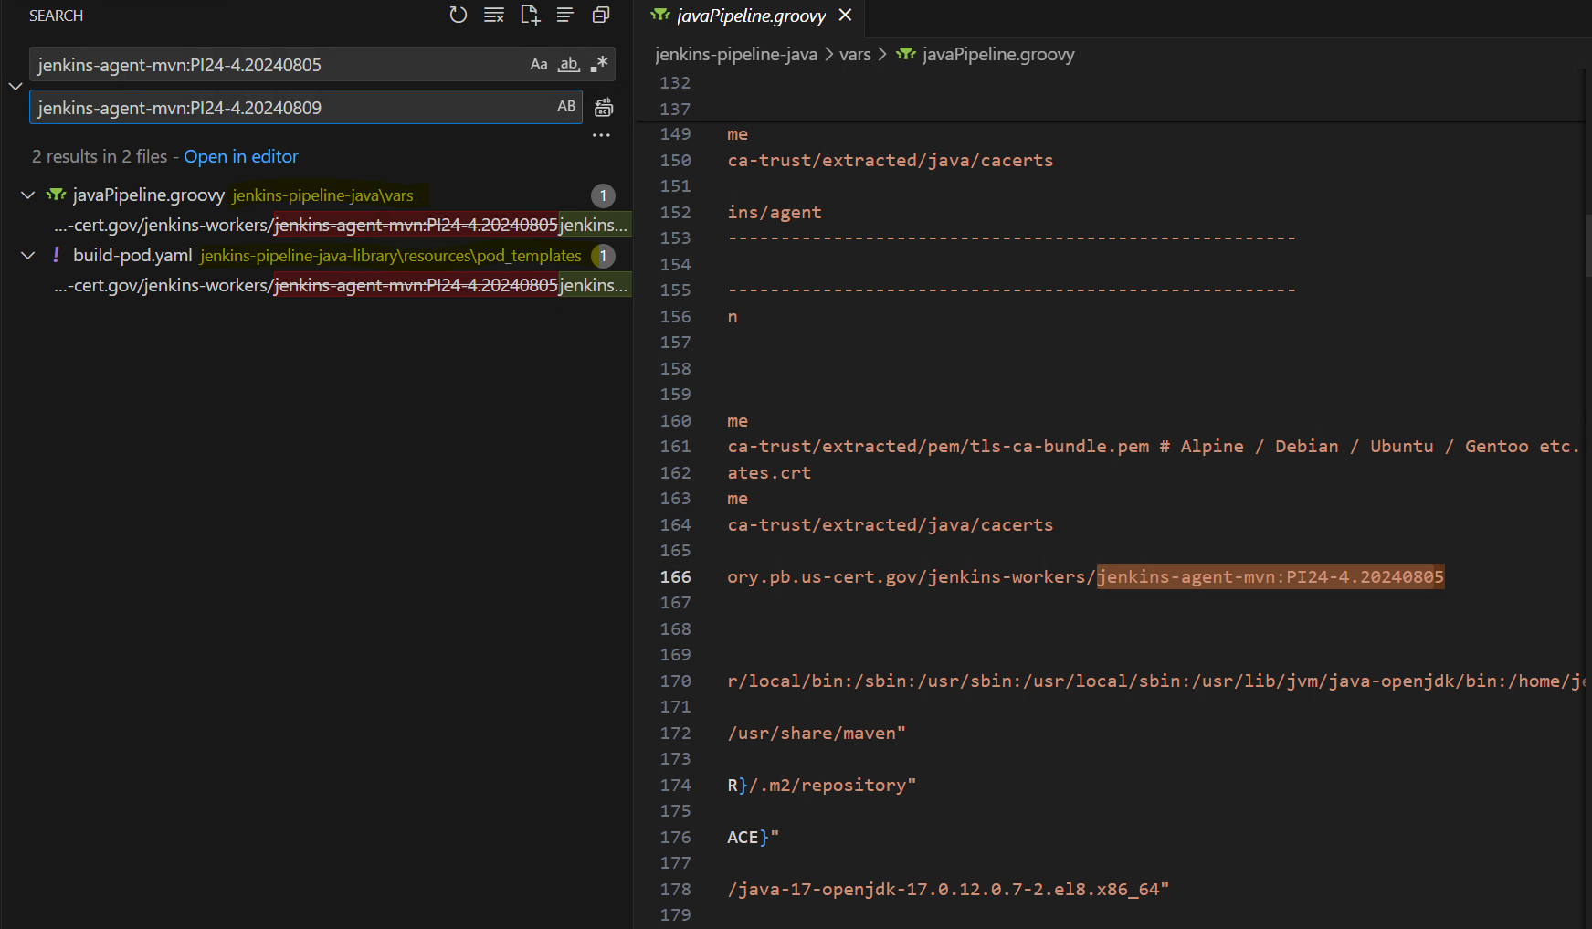

Cloudbees Successful Builds for Datascience - AMS EMR Analytic Runner

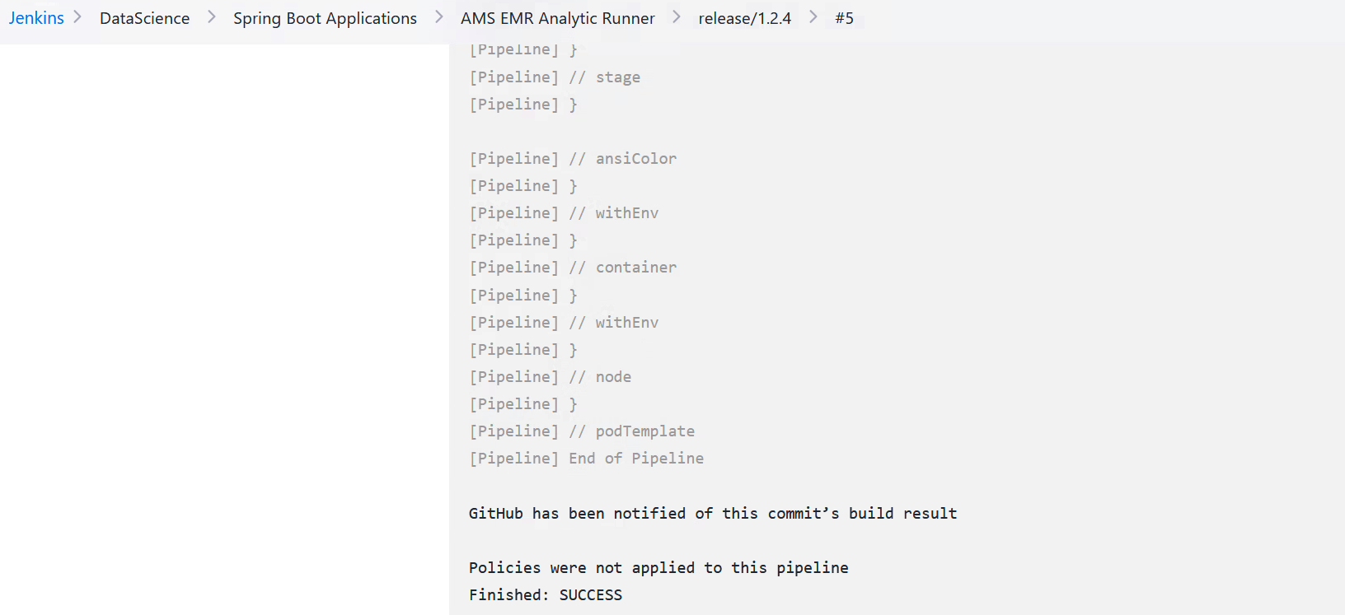

===========================================================================================================================

Error:

+ mvn install -B -Dorg.slf4j.simpleLogger.log.org.apache.maven.cli.transfer.Slf4jMavenTransferListener=warn The JAVA_HOME environment variable is not defined correctly, this environment variable is needed to run this program.

Solution:

I updated the JAVA_HOME path to be the latest version of Java-17 used inside the Docker Image, and I updated this JAVA_HOME inside the java-pipeline-java-library pipeline, since this project was using this pipeline for Cloudbees Build.
The pipeline-java-library pipeline was using the WRONG version path of JAVA-17 as shown below inside the jenkins-agent-mvn worker agent.

- Wrong JAVA Version Path = 17.0.11.0.9-2
- Correct JAVA Version Path = 17.0.12.0.7-2

- Updating Jenkins Pipelines - Develop & Master Branch
  - Jenkins-pipeline-java-library

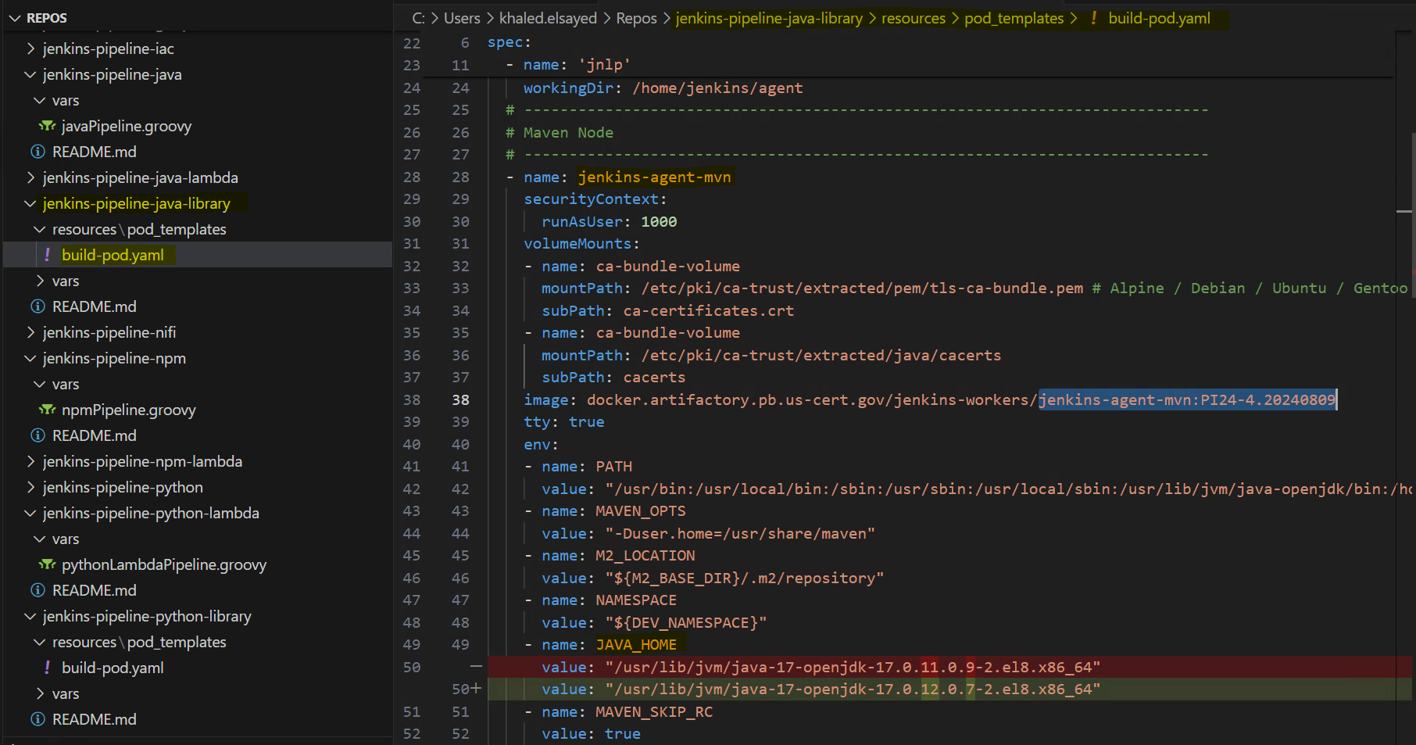

===========================================================================================================================

Error:

This happened in CDMA-IPA Repo in ECC, for the Navigator App which is an NPM application.

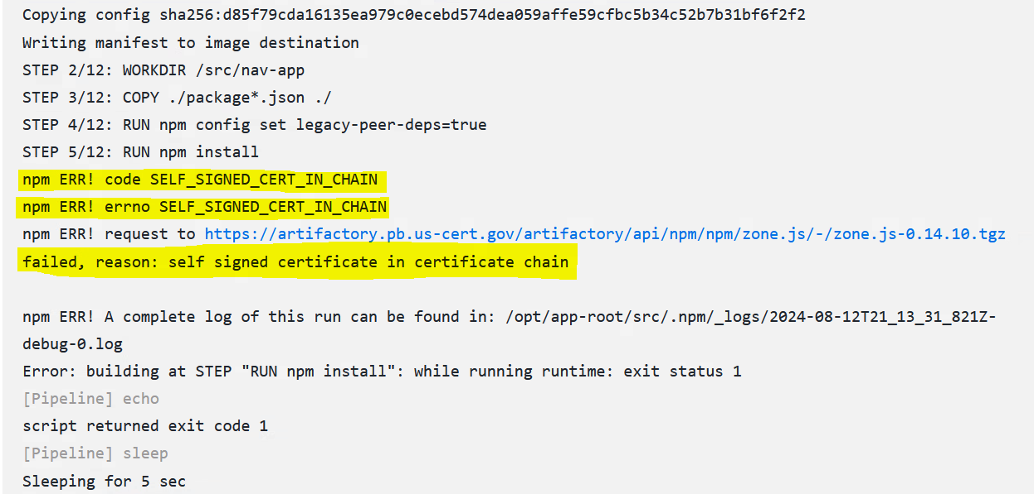

STEP 4/12: RUN npm config set legacy-peer-deps=true
STEP 5/12: RUN npm install npm ERR! code SELF_SIGNED_CERT_IN_CHAIN
npm ERR! errno SELF_SIGNED_CERT_IN_CHAIN npm ERR! request to https://artifactory.pb.us-cert.gov/artifactory/api/npm/npm/zone.js/-/zone.js-0.14.10.tgz failed, reason: self signed certificate in certificate chain

Solution:

I added the following configurations inside their Dockerfile, to avoid the cert issue.

RUN npm config set strict-ssl false
RUN npm cache clean --force
RUN npm install --force

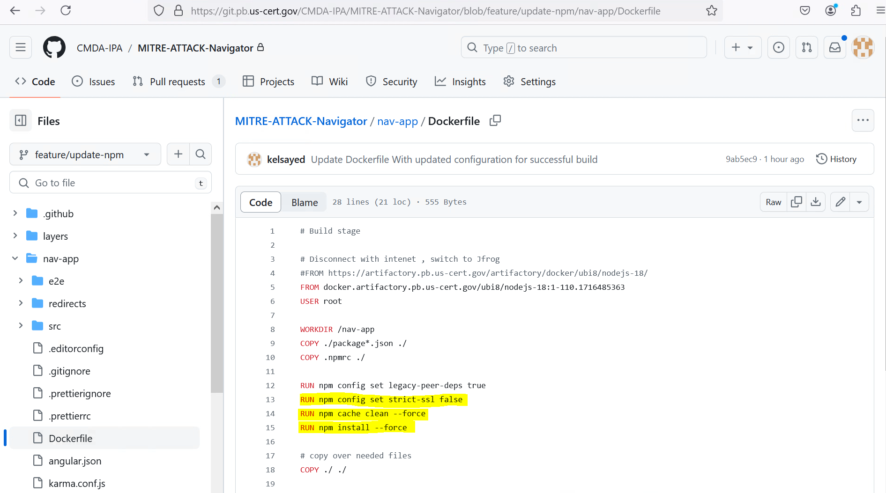

===========================================================================================================================
Error:

This happened in CDMA-IPA Repo in ECC, for the Navigator App which is an NPM application.

STEP 1/14: FROM docker.artifactory.pb.us-cert.gov/ubi8/nodejs-18:1-110.1716485363 STEP 2/14:
WORKDIR /nav-app STEP 3/14: COPY ./package*.json ./ STEP 4/14:
RUN npm config set legacy-peer-deps true STEP 5/14:
RUN npm config set strict-ssl false STEP 6/14:
RUN npm cache clean --force
npm WARN using --force Recommended protections disabled.
STEP 7/14: RUN npm install --force
npm WARN using --force Recommended protections disabled.
npm ERR! code E401
npm ERR! Incorrect or missing password.
npm ERR! If you were trying to login, change your password, create an
npm ERR! authentication token or enable two-factor authentication then
npm ERR! that means you likely typed your password in incorrectly.
npm ERR! Please try again, or recover your password at:
npm ERR! https://www.npmjs.com/forgot npm ERR!
npm ERR! If you were doing some other operation then your saved credentials are
npm ERR! probably out of date. To correct this please try logging in again with:
npm ERR! npm login npm ERR! A complete log of this run can be found in: /opt/app-root/src/.npm/_logs/2024-08-15T20_22_55_040Z-debug-0.log Error: building at STEP "RUN npm install --force": while running runtime: exit status 1

Solution:

I added the following attributes to the Docker file. The main fix was copying the .npmrc file from the jenkins-agent-npm12 to the docker container, to make sure we set the docker registry as artifactory.pb.us-cert.gov and not npmjs.org because we are not allowed to get packages from internet. Everything has to go through Artifactory.

- USER root
- COPY .npmrc ./
- USER 1000

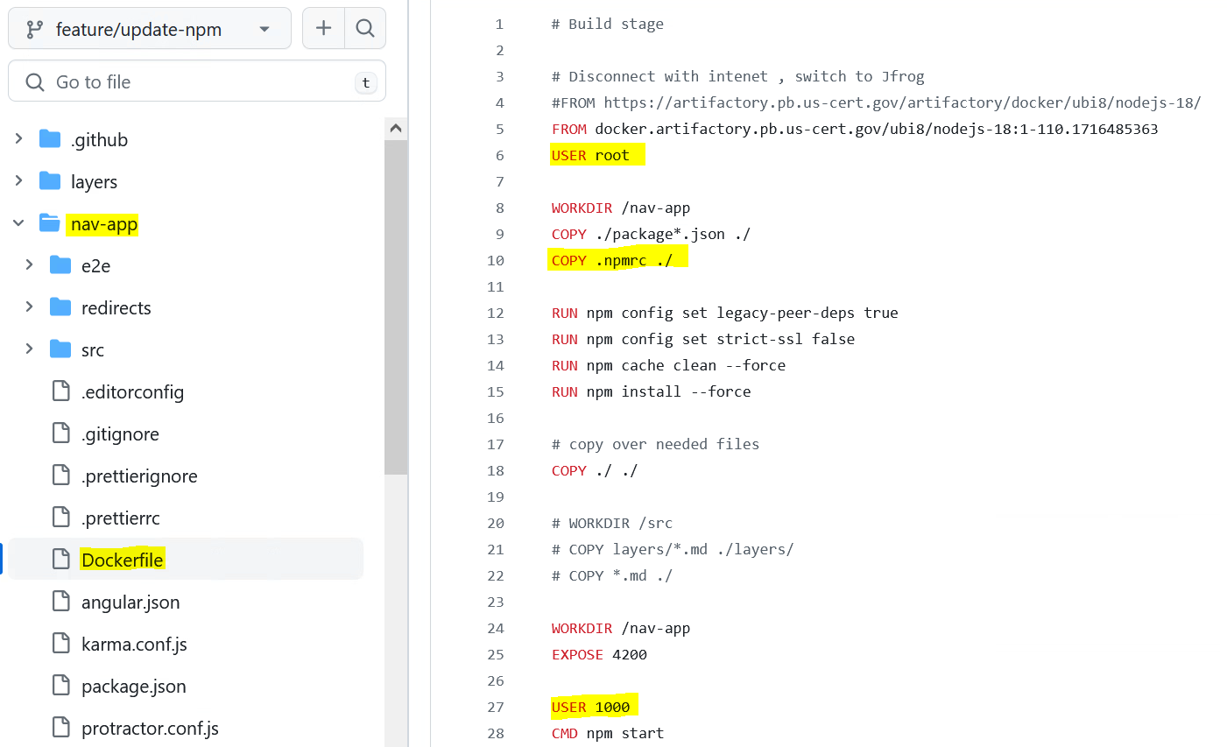

Jenkins-agent-npm12

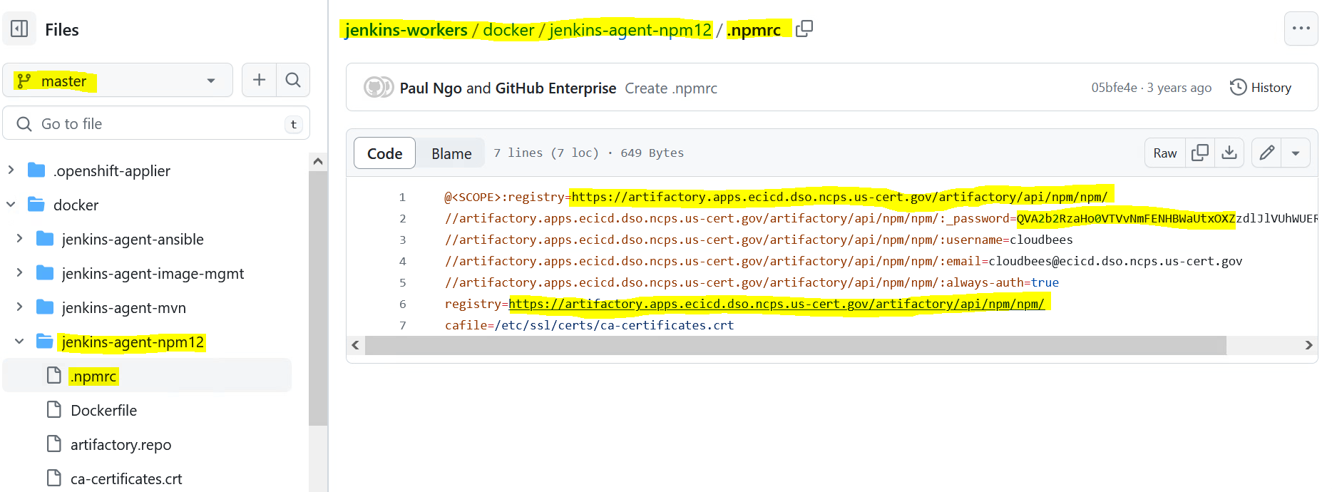

===========================================================================================================================

Error:

STEP 10/16: COPY ./ ./
STEP 11/16: COPY layers/*.md ./layers/
Error: building at STEP "COPY layers/*.md ./layers/": checking on sources under "/home/jenkins/agent/workspace/navigator_feature_update-npm/nav-app": Rel: can't make relative to /home/jenkins/agent/workspace/navigator_feature_update-npm/nav-app; copier: stat: ["/layers/*.md"]: no such file or directory
[Pipeline] echo
script returned exit code 125
[Pipeline] sleep Sleeping for 5 sec

Solution:

I commented out the following lines because the layers directory was outside the nav-app directory.

- WORKDIR /src
- COPY Layers/*.md ./layers and
- COPY *.md ./

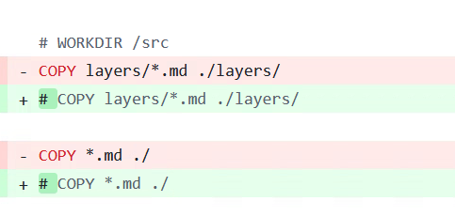

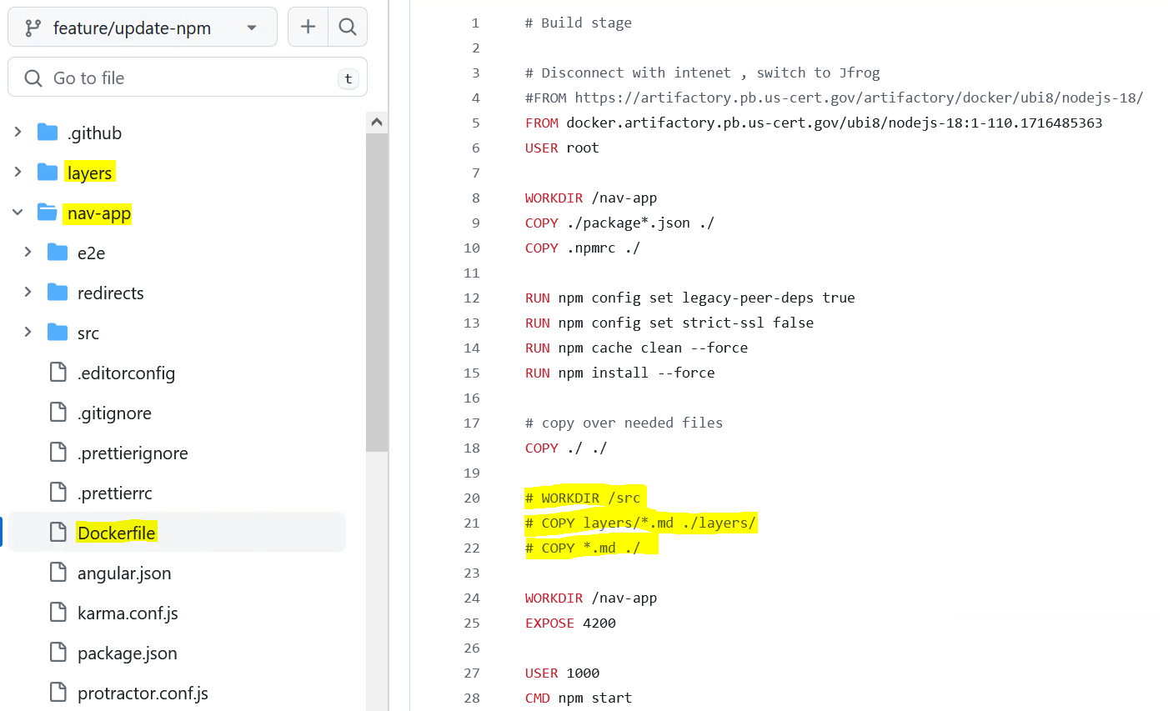

===========================================================================================================================

Error:

[Pipeline] // node
[Pipeline] }
[Pipeline] // podTemplate
[Pipeline] End of Pipeline
Also: org.jenkinsci.plugins.workflow.actions.ErrorAction$ErrorId: b5b2cb2e-687c-4ad5-823b-a4835fac2eb7
java.lang.NoSuchMethodError: No such DSL method 'prismaCloudScanImage' found among steps [ansiColor, ansibleAdhoc, ansiblePlaybook, ansibleVault, archive, awaitDeploymentCompletion, awsIdentity, bat, build, catchError, cfInvalidate, cfnCreateChangeSet, cfnDelete, cfnDeleteStackSet, cfnDescribe, cfnExecuteChangeSet, cfnExports, cfnUpdate, cfnUpdateStackSet, cfnValidate, checkout, checkpoint, cloudBeesFlowCallRestApi, compareVersions, container, containerLog, copyRemoteArtifacts, createDeployment, currentUserGlobalRoles, currentUserItemRoles, deleteDir, deployAPI, dir, ebCreateApplication, ebCreateApplicationVersion, ebCreateConfigurationTemplate, ebCreateEnvironment, ebSwapEnvironmentCNAMEs, ebWaitOnEnvironmentHealth, ebWaitOnEnvironmentStatus, ec2ShareAmi, echo, ecrDeleteImage, ecrListImages, ecrLogin, ecrSetRepositoryPolicy, elbDeregisterInstance, elbIsInstanceDeregistered, elbIsInstanceRegistered, elbRegisterInstance, emailext, emailextrecipients, envVarsForTool, error, fileExists, findBuildScans, findFiles, getContext, git, input, invokeLambda, isUnix, junit, lambdaVersionCleanup, librar

Solution:

Install Prisma Cloud Scan Plugin on the controller.

=========================================================================================================================

Cloudbees Build Link:
-------------------------------

https://cloudbees.pb.lz.us-cert.gov/datart/job/uads/job/uads-ui/job/feature%252Fvite-build/6/console

Error:

Running in /home/jenkins/agent/workspace/uads_uads-ui_feature_vite-build
[Pipeline] {
[Pipeline] sh
+ cp /home/jenkins/.npmrc .
[Pipeline] sh
+ npm install --no-optional --no-shrinkwrap --no-package-lock --legacy-peer-deps
npm warn config optional Use `--omit=optional` to exclude optional dependencies, or
npm warn config `--include=optional` to include them.
npm warn config
npm warn config Default value does install optional deps unless otherwise omitted.
npm warn config shrinkwrap Use the --package-lock setting instead.
npm error code 1
npm error path /home/jenkins/agent/workspace/uads_uads-ui_feature_vite-build/node_modules/esbuild
npm error command failed
npm error command sh -c node install.js
npm error /home/jenkins/agent/workspace/uads_uads-ui_feature_vite-build/node_modules/esbuild/install.js:136
npm error throw new Error(`Expected ${JSON.stringify(versionFromPackageJSON)} but got ${JSON.stringify(stdout)}`);
npm error ^
npm error
npm error Error: Expected "0.25.10" but got "0.25.5"
npm error at validateBinaryVersion (/home/jenkins/agent/workspace/uads_uads-ui_feature_vite-build/node_modules/esbuild/install.js:136:11)
npm error at /home/jenkins/agent/workspace/uads_uads-ui_feature_vite-build/node_modules/esbuild/install.js:285:5
npm error
npm error Node.js v20.19.2
npm error A complete log of this run can be found in: /home/jenkins/.npm/_logs/2025-10-14T13_09_28_469Z-debug-0.log
[Pipeline] }

Solution:

We added the esbuild package with a version = 0.25.5 in the package. Json file to solve this issue.

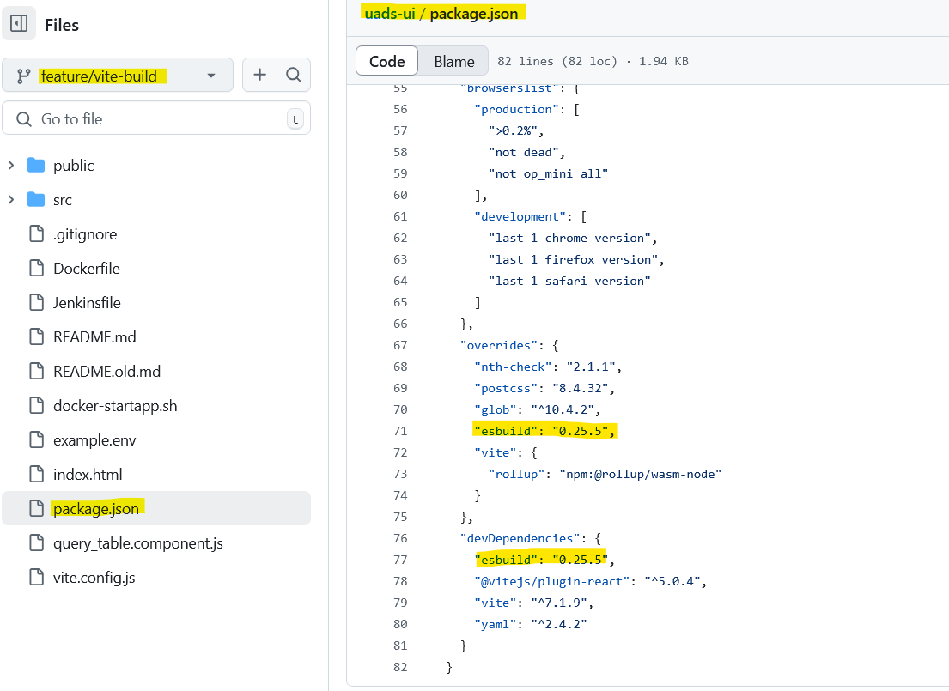

khaled.fouad ~/Documents/Repos/Applications/DATART/DATART-App/uads-ui (feature/vite-build) ❯ npm install --no-optional --no-shrinkwrap --no-package-lock --legacy-peer-deps --verbose

npm verbose cli /usr/bin/node /usr/bin/npm
npm info using npm@10.8.2
npm info using node@v20.19.2
npm warn config optional Use `--omit=optional` to exclude optional dependencies, or
npm warn config `--include=optional` to include them.
npm warn config
npm warn config Default value does install optional deps unless otherwise omitted.
npm warn config shrinkwrap Use the --package-lock setting instead.
npm verbose title npm install
npm verbose argv "install" "--no-optional" "--no-shrinkwrap" "--no-package-lock" "--legacy-peer-deps" "--loglevel" "verbose"
npm verbose logfile logs-max:10 dir:/home/khaled.elsayed.rh/.npm/_logs/2025-10-15T19_28_14_570Z-
npm verbose logfile /home/khaled.elsayed.rh/.npm/_logs/2025-10-15T19_28_14_570Z-debug-0.log

Cloudbees Build Link for NPM test:
------------------------------------------------
This build include the test script that is being executed by npm.

The test script is added in the scripts section, and the devDependencies section.

Running in /home/jenkins/agent/workspace/uads_uads-ui_feature_vite-build
[Pipeline] {
[Pipeline] script
[Pipeline] {
[Pipeline] sh
+ npm run test
> uads-ui@0.1.0 test
> vitest --run --passWithNoTests
RUN v3.2.4 /home/jenkins/agent/workspace/uads_uads-ui_feature_vite-build
No test files found, exiting with code 0
include: **/*.{test,spec}.?(c|m)[jt]s?(x)
exclude: **/node_modules/**, **/dist/**, **/cypress/**, **/.{idea,git,cache,output,temp}/**, **/{karma,rollup,webpack,vite,vitest,jest,ava,babel,nyc,cypress,tsup,build,eslint,prettier}.config.*

The test script is added in the scripts section, and the devDependencies section in the package.json file.

